

| **Title:**  **Implementation of support vector machine** |
| --- |

**Objective:** To create a model for classification using support vector machine.

**Expected Outcome of Experiment:**

| **CO** | **Outcome** |
| --- | --- |
| **CO1** | Describe and apply supervised learning methods |

**Books/ Journals/ Websites referred:**

[**https://towardsdatascience.com/support-vector-machine-explained-8bfef2f17e71**](https://towardsdatascience.com/support-vector-machine-explained-8bfef2f17e71)

<https://www.analyticsvidhya.com/blog/2021/10/support-vector-machinessvm-a-complete-guide-for-beginners/>

**Theory of Support Vector Machine:**

Support Vector Machine (SVM) is a powerful supervised learning algorithm primarily used for classification tasks, though it can be extended to regression and outlier detection. The core idea behind SVM is to find the hyperplane that best separates different classes in the feature space while maximizing the margin, which is the distance between the hyperplane and the nearest data points from each class, known as support vectors.

SVM aims to find the optimal hyperplane by solving a convex optimization problem, where the objective is to minimize the classification error while maximizing the margin. This is achieved by introducing slack variables that allow for some misclassification of data points, penalized by a regularization parameter.

One of the key strengths of SVM is its ability to handle high-dimensional data efficiently, making it suitable for complex classification problems even with a small dataset. Additionally, SVM is robust to overfitting, thanks to its margin maximization objective, and it performs well in cases where the data is not linearly separable by using kernel tricks to map the data into a higher-dimensional space where separation is possible.

However, SVM has some limitations, including its sensitivity to the choice of kernel and parameters, and its computational complexity can be high for large datasets. Furthermore, SVM is not inherently probabilistic, so additional techniques like Platt scaling or cross-validation are often used to estimate class probabilities.

**Details of data set used: Sample dataset**

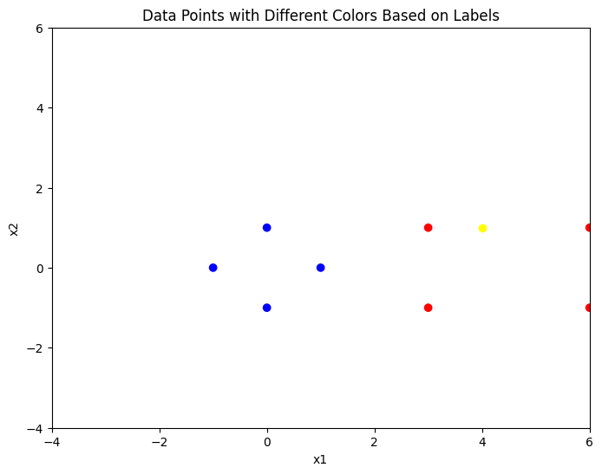

**Explanation of API/Tool used for implementation:**

np.linalg tool is used for solving linear equations

**Results:** SVM classifier makes a SVM line

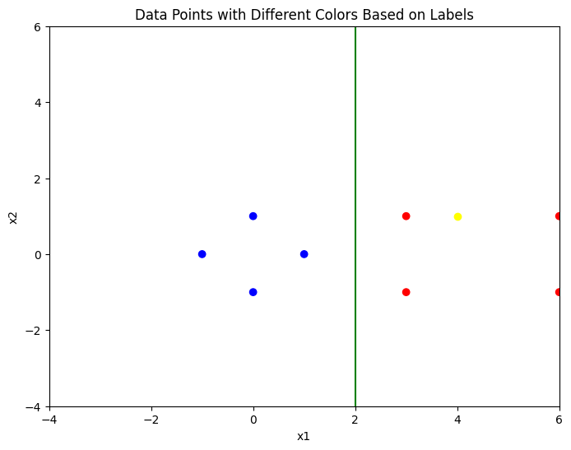

**Conclusion:** In this experiment, we have implemented simple linear SVM. We have coded it from scratch without using direct library functions.

In summary, SVM offers a powerful framework for classification tasks by finding an optimal hyperplane that maximizes the margin between different classes, making it widely used in various fields such as image recognition, text categorization, and bioinformatics.